SUMMERLIN WOODS CONDOMINIUM ASSOCIATION, INC.
(EXECUTIVE SUITES at WORLD PLAZA)
12553 NEW BRITTANY BLVD., #32, FORT MYERS, FL 33907
Email: summerlinwoods@gmail.com www: summerlinwoodsfortmyers.com
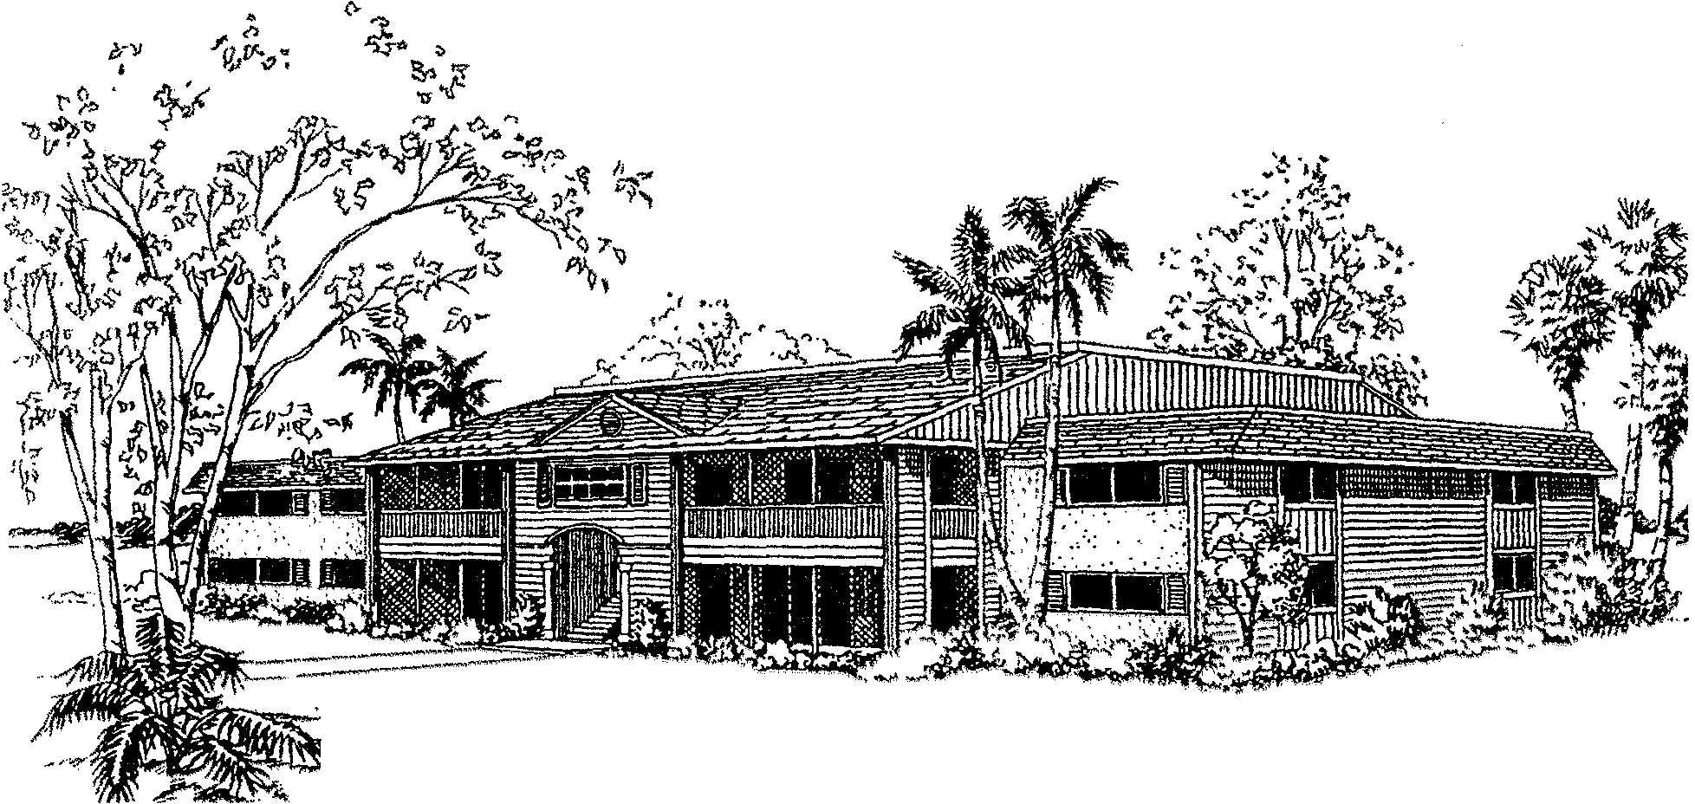
Emergency Contact Information
Date: _______________
Building & Unit Number: ________________________________________________________________
Unit Owner Name: _____________________________________________________________________
Phone Number: ______________________________ Email: ____________________________________
Occupancy Status: Full Time: ___________ Part Time: _________ Investment Rental: _______________

=====================================================================================
CONTACT PERSON NAME: _______________________________ RELATIONSHIP: ___________________
ADDRESS: ____________________________________________________________________________
PHONE NUMBER: ___________________________ EMAIL: ____________________________________

CONTACT PERSON NAME: _______________________________ RELATIONSHIP: ___________________
ADDRESS: ____________________________________________________________________________
PHONE NUMBER: ___________________________ EMAIL: ____________________________________

ADDITIONAL INFORMATION: ____________________________________________________________________________________________________________________________________________________________________________________________________________________________________________________________________________________________________________________________________________________

